Final project report

In this project of recognizing mathematical equations in handwritten images, the work of my group is divided into 3 clear parts. The first part is called data preparation, and this is where we pre-process the images from the training set. Each equation is divided into several images of symbols, and, furthermore, segmented images will go through two crucial precedures for future operation. During annotation, each image is labeled with the name of the original equation, from which it was abstracted, along with the symbol that it stands for, and lastly, the four coordinates of the symbol in the original picture.(Shown as below:)
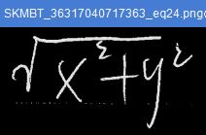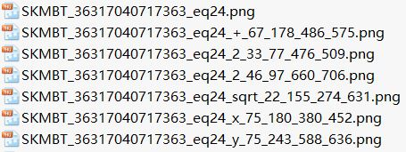
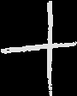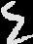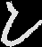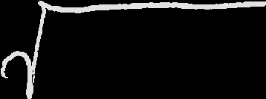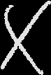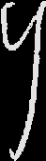
After annotation, each image of symbol is padded to be a png file of 32 pixel by 32 pixel, flattened to a numerical expression of colors, and filled into a np array.

The second part of the work is modeling. The basic architecture is keras resnet. With the help of keras framework, we are able to build up a classifier that identifies the required digits, characters and operational symbols.

In the third part of this project, segmentation, suppose we are testing following image:
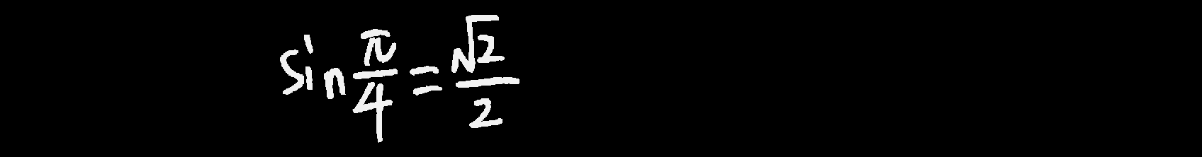
Before applying the model on the image, we need to cut image into pieces of symbol images:
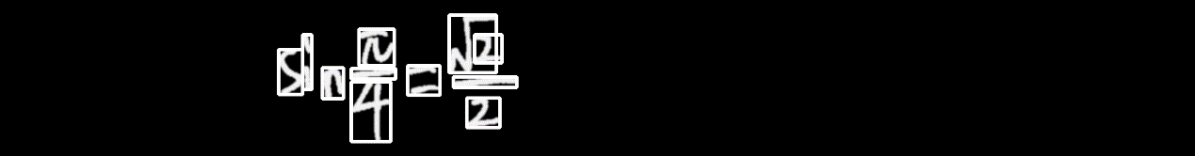
This way, we can recognize every single symbol.

To achieve this, first we call findCountour() in openCV class. This gives us a list of contours. Using this list, we cut image pieces from the image. Now we have:
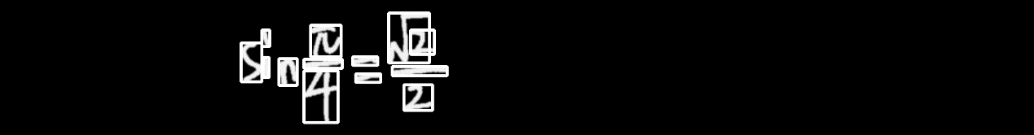
Here are two problems:
- Symbols having separate parts won’t be recognized, like “i” and “=”.
- For single image piece that is cut out, we may have something we don’t want, like:
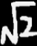
while we need “sqrt” only.
To solve problem 2: we used label() to convert each continue shape into single digits. Since there is only 1 such digit appearing on all four edges of the image piece, we can find it and keep it only. This way, we can erase “2” and have:
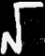
To solve problem 1: we check if the image piece is bar-shaped. If so, we conjugate if with other bar pieces. If they mostly overlap horizontally, we combine them. This way, we have:
and 